Rising Waters: A Machine Learning Approach to Flood Prediction
Project Description:
One of the most critical challenges which affects our country's safety and socio-economic development is the natural disaster management system, particularly flood prediction and prevention. The process of accurate flood forecasting is gaining recognition across disaster management organizations globally. "As we know flood prediction is very crucial, there are variety of techniques are used for risk level assessment. In addition, flood risk management is one of the main functions of the disaster management community.
The prediction of flood occurrences is one of the difficult tasks for any meteorological department. But by forecasting the flood events accurately, the authorities definitely may reduce its impact by implementing timely evacuation measures, so that prevention and mitigation activities can take place without any loss of life and it can play as the contributing parameter of disaster preparedness. This makes the study of this flood prediction important. Machine Learning techniques are very crucial and useful in prediction of these type of environmental data.
We will be using classification algorithms such as Decision tree, Random Forest, KNN, and XGBoost. We will train and test the data with these algorithms. From this best model is selected and saved in pkl format. We will be doing Flask integration and web deployment.
Technical Architecture:
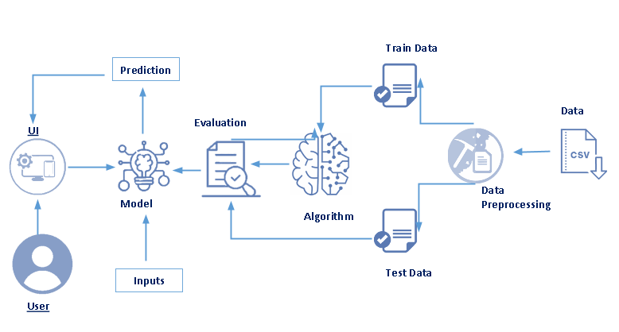
Pre-requisites:
To complete this project, you must have the following software, concepts and packages:
• Anaconda Navigator and PyCharm:
- Refer the link below to download Anaconda Navigator
- Link: https://youtu.be/1ra4zH2G4o0

• Python Packages:
- Open Anaconda prompt as administrator
- Type "pip install NumPy" and click enter.
- Type "pip install pandas" and click enter.
- Type "pip install scikit-learn" and click enter.
- Type "pip install matplotlib" and click enter.
- Type "pip install SciPy" and click enter.
- Type "pip install pickle-mixin" and click enter.
- Type "pip install seaborn" and click enter.
- Type "pip install Flask" and click enter.
Prior Knowledge:
You must have prior knowledge of following topics to complete this project.
- ML Concepts
  - Supervised learning: https://www.javatpoint.com/supervised-machine-learning
  - Unsupervised learning: https://www.javatpoint.com/unsupervised-machine-learning
  - Regression and classification
- Decision tree: https://www.javatpoint.com/machine-learning-decision-tree-classification-algorithm
- Random forest: https://www.javatpoint.com/machine-learning-random-forest-algorithm
- KNN: https://www.javatpoint.com/k-nearest-neighbor-algorithm-for-machine-learning
- XGBoost: https://www.analyticsvidhya.com/blog/2018/09/an-end-to-end-guide-to-understand-the-math-behind-xgboost/
- Evaluation metrics: https://www.analyticsvidhya.com/blog/2019/08/11-important-model-evaluation-error-metrics/
- Flask Basics : https://www.youtube.com/watch?v=lj4I_CvBnt0
Project Objectives:
By the end of this project, you will:
- Know fundamental concepts and techniques used for machine learning.
- Gain a broad understanding about data.
- Have knowledge on pre-processing the data/transformation techniques on outlier and some visualization concepts.

Project Flow:
• User interacts with the UI to enter the input.
• Entered input is analyzed by the model which is integrated.
• Once model analyzes the input, the flood prediction is showcased on the UI.
To accomplish this, we have to complete all the activities listed below:
• Data Collection
- Collect the dataset or create the dataset
• Visualizing and Analyzing Data
- Univariate analysis
- Bivariate analysis
- Multivariate analysis
- Descriptive analysis
• Data Pre-processing
- Checking for null values
- Handling outliers
- Handling categorical data
- Splitting data into train and test
• Model Building
- Import the model building libraries
- Initializing the model
- Training and testing the model
- Evaluating performance of model
- Save the model
• Application Building
- Create an HTML file
- Build Python code

Project Structure:
Create the Project folder which contains files as shown below
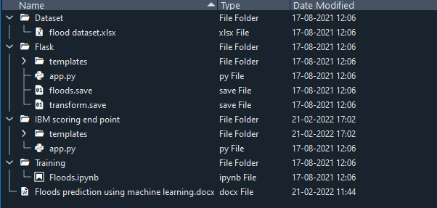
• We are building a Flask application which needs HTML pages stored in the templates folder and a Python script app.py for scripting.
• floods.save and transform.save are our saved models. Further we will use these models for Flask integration.
• Training folder contains model training files (Floods.ipynb) for the flood prediction model development.
Milestone 1: Data Collection
ML depends heavily on data. It is the most crucial aspect that makes algorithm training possible. So this section allows you to download the required dataset.
Activity 1: Download the Dataset
There are many popular open sources for collecting the data. E.g.: kaggle.com, UCI repository, etc.
In this project we have used flood prediction dataset. This data is downloaded from kaggle.com. Please refer to the link given below to download the dataset.
Link: https://www.kaggle.com/datasets/arbethi/rainfall-dataset
Milestone 2: Visualizing and Analyzing the Data
As the dataset is downloaded, let us read and understand the data properly with the help of some visualization techniques and some analyzing techniques.
Note: There are n number of techniques for understanding the data. But here we have used some of them. In an additional way, you can use multiple techniques.

Activity 1: Importing the libraries
Import the necessary libraries as shown in the image. (optional) Here we have used visualization style as fivethirtyeight.
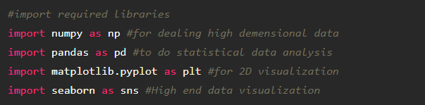

Activity 2: Read the Dataset
Our dataset format might be in .csv, excel files, .txt, .json, etc. We can read the dataset with the help of pandas.
In pandas we have a function called read_csv() to read the dataset. As a parameter we have to give the directory of csv file.
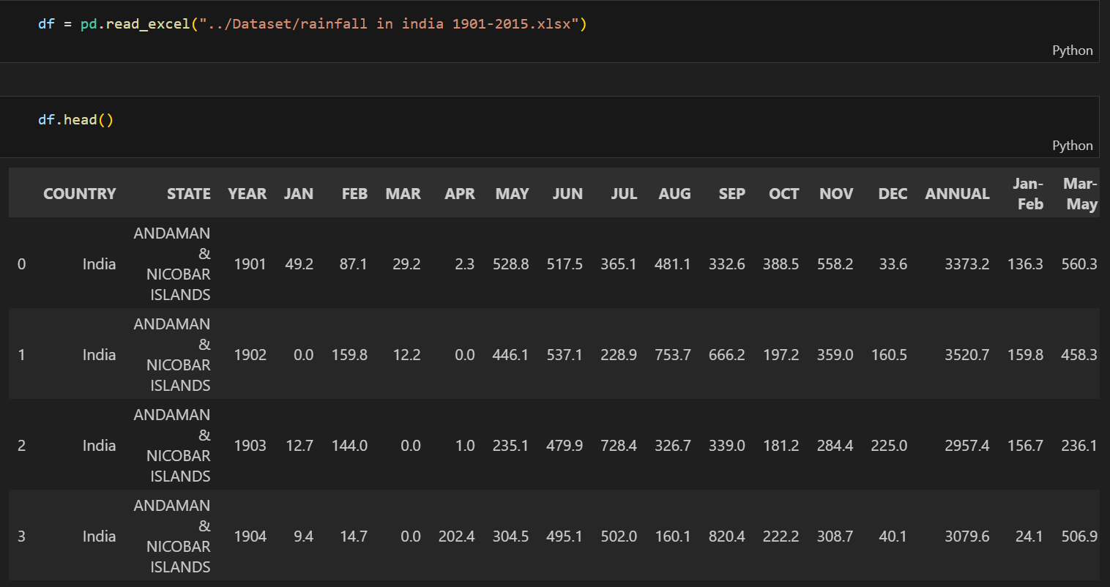

Activity 3: Univariate Analysis
In simple words, univariate analysis is understanding the data with single feature. Here we have displayed two different graphs such as distplot and countplot.
• Seaborn package provides a wonderful function distplot. With the help of distplot, we can find the distribution of the feature. To make multiple graphs in a single plot, we use subplot.

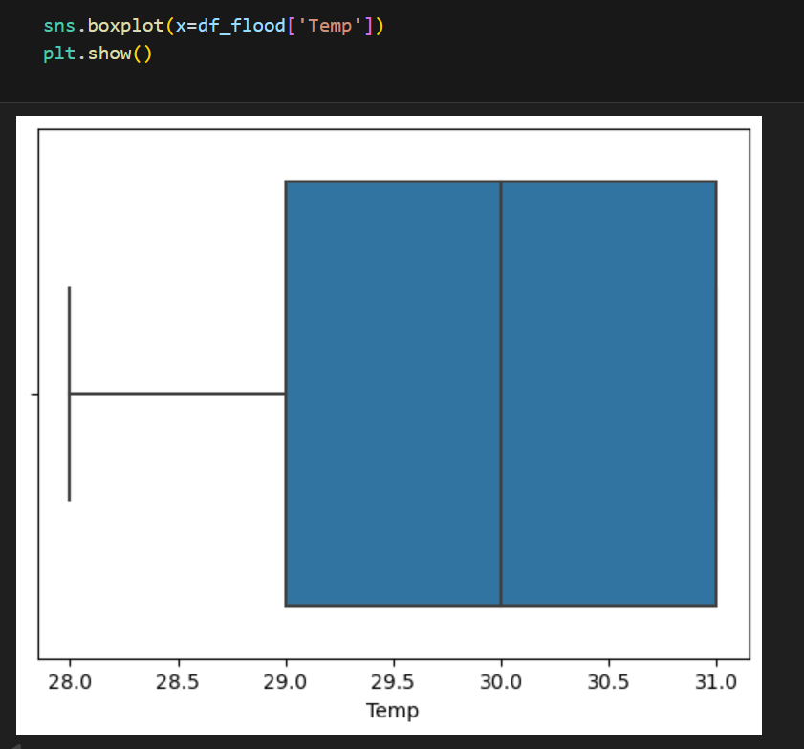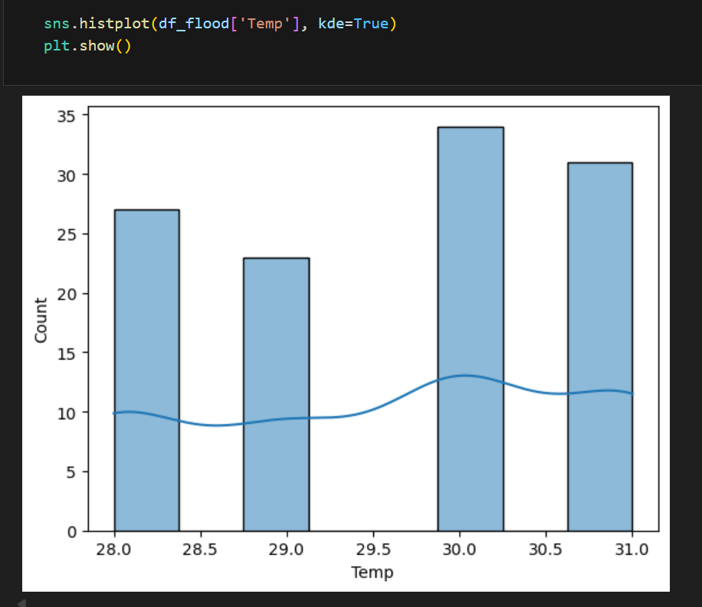

• In our dataset we have some categorical features. With the count plot function, we are going to count the unique category in those features. We have created a dummy data frame with categorical features. With for loop and subplot we have plotted this below graph.
• From the plot we came to know, rainfall and water level features are skewed towards left side, whereas flood occurrence is categorical with binary values indicating flood or no flood conditions.

Countplot:
A count plot can be thought of as a histogram across a categorical, instead of quantitative, variable. The basic API and options are identical to those for bar plot(), so you can compare counts across nested variables.
From the graph we can infer that flood occurrence and sewer overflow are categorical variables with 2 categories. From the flood occurrence column we can infer that 0-category (no flood) is having more weightage than category-1 (flood occurred), while sewer overflow with 0, it means no overflow is a predominant class when compared with category-1, which indicates sewer overflow condition.

Activity 4: Multivariate Analysis (Correlation Heatmap)
From the correlation heatmap, we can analyze the relationships between multiple variables simultaneously and their correlation with flood occurrence. The heatmap displays correlation coefficients ranging from -1 to +1, where values closer to +1 indicate strong positive correlation, values closer to -1 indicate strong negative correlation, and values near 0 indicate weak or no correlation.
From the visualization, we can observe which features have the strongest correlation with flood events. Features like rainfall, temperature, and water level show their degree of correlation with the target variable (flood). This helps us identify the most important features that contribute to flood prediction and understand how different environmental factors interact with each other.

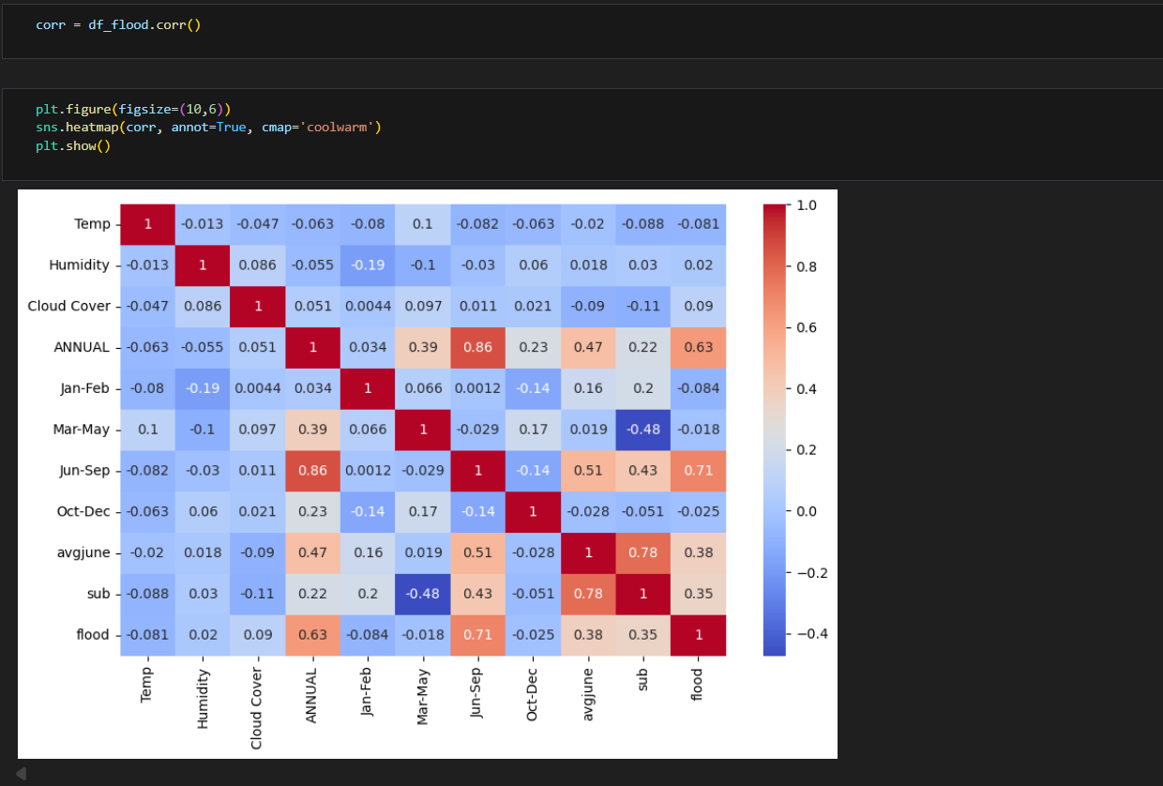

Activity 5: Multivariate analysis
In simple words, multivariate analysis is to find the relation between multiple features. Here we have used correlation heatmap from seaborn package.
From the above graph we are plotting the relationship between multiple environmental factors such as temperature, rainfall, water level, and their correlation with flood occurrence. The heatmap displays correlation coefficients that help us understand how these variables interact with each other and with the target variable (flood).

Activity 6: Descriptive analysis
Descriptive analysis is to study the basic features of data with the statistical process. Here pandas has a worthy function called describe. With this describe function we can understand the unique, top and frequent values of categorical features. And we can find mean, std, min, max and percentile values of continuous features.
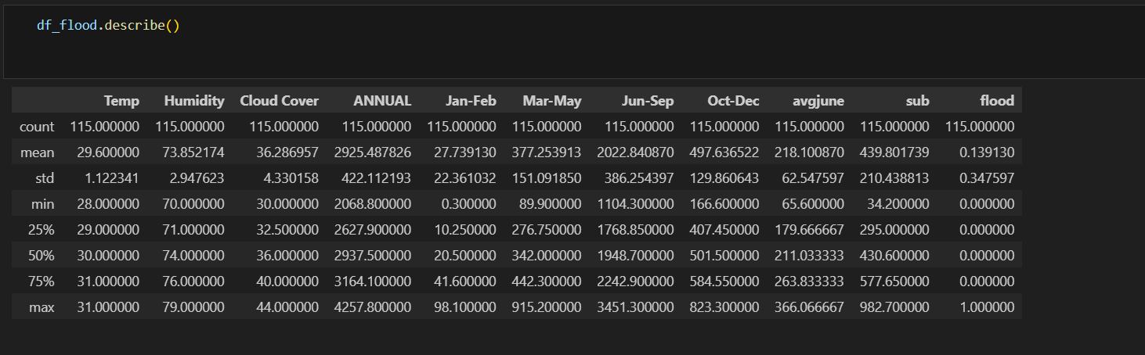
Milestone 3: Data Pre-processing
As we have understood how the data is, let's pre-process the collected data.
The downloaded dataset is not suitable for training the machine learning model as it might have so much randomness, so we need to clean the dataset properly in order to fetch good results. This activity includes the following steps:
• Handling missing values
• Handling categorical data
• Handling outliers
• Scaling Techniques
• Splitting dataset into training and test set

Activity 1: Checking for null values
- Let’s find the shape of our dataset first, To find the shape of our data, df.shape method is used. To find the data type, df.info() function is used.
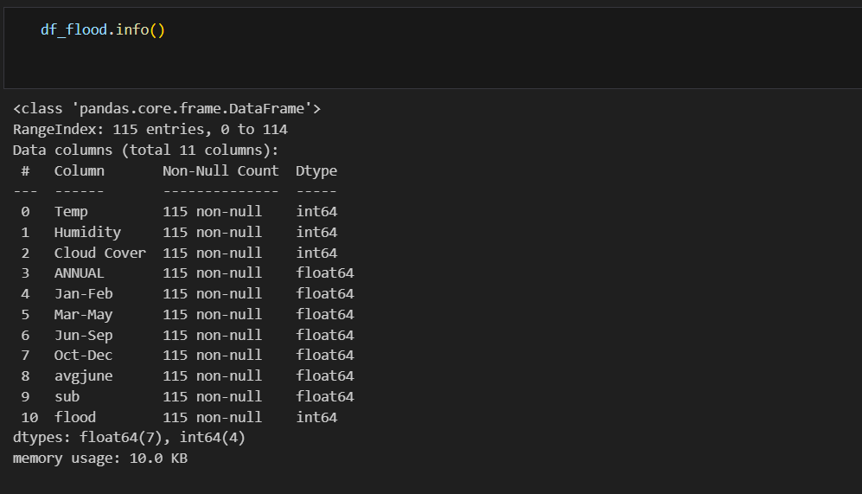

• For checking the null values, df.isnull() function is used. To sum those null values we use .sum() function to it. From the below image we found the presence of null values in our dataset. We handle these missing values by filling them with the mean of respective columns using fillna() function. After handling, we verify again to ensure all null values have been properly addressed.
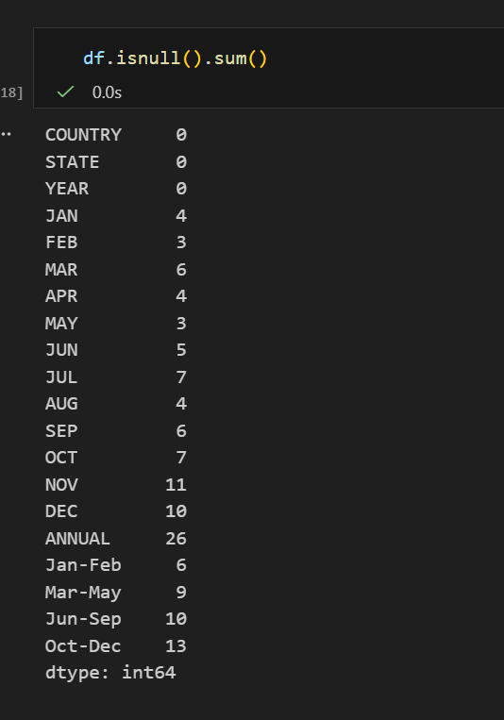
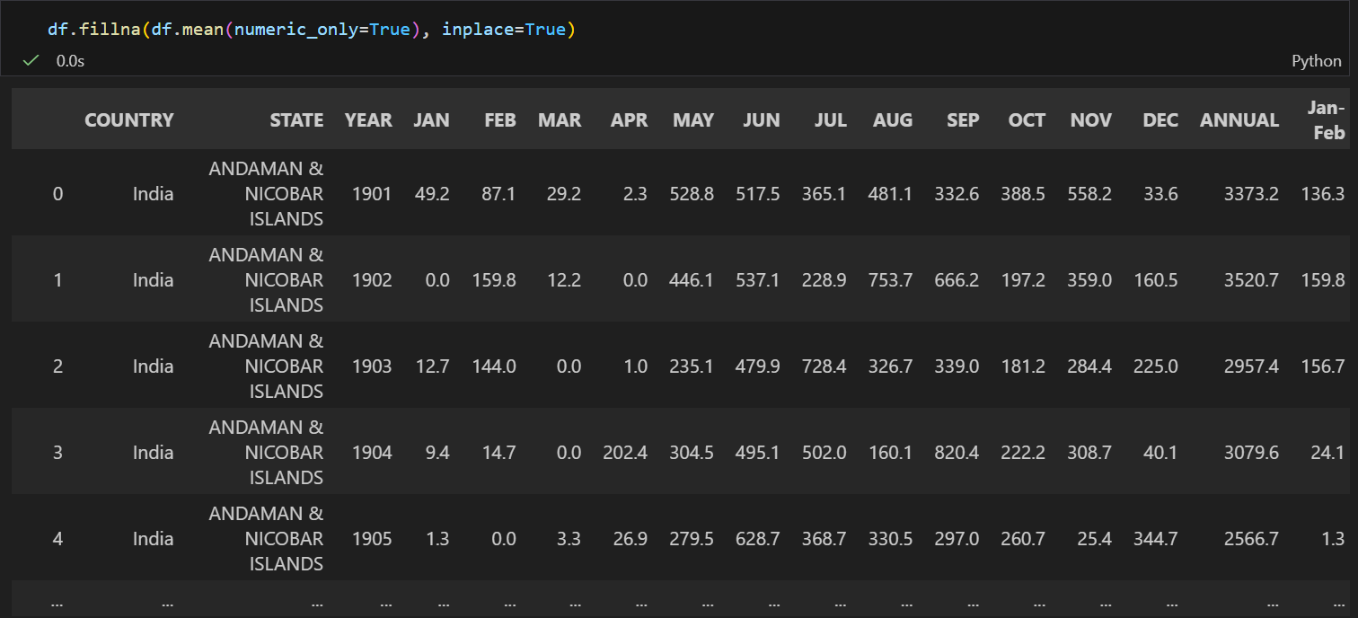
From the above code of analysis, we can infer that the rainfall dataset contains missing values in various columns representing monthly and seasonal rainfall data. We need to treat them in a required way.
We will fill the missing values in numeric data type using mean value of that particular column. Since our flood dataset primarily consists of numerical environmental features (temperature, rainfall, water level, etc.), we apply the mean imputation strategy to maintain the statistical distribution of the data without introducing bias.
Activity 2: Handling Categorical Values
As we can see, our dataset primarily consists of numerical environmental data. However, if the dataset contains any categorical features such as region codes, flood zones, or weather conditions, we must convert the categorical data to integer encoding or binary encoding.
To convert categorical features into numerical features, we use encoding techniques. There are several techniques, but in our project, the flood dataset is already preprocessed with numerical values for all features including temperature, rainfall, water level, and other environmental parameters. The target variable 'flood' is also encoded as binary (0 for no flood, 1 for flood occurrence).
• In our flood prediction dataset, all features are numerical, eliminating the need for manual encoding. We can directly proceed to feature scaling and model training steps.

Activity 3: Splitting Data into Train and Test
Now let's split the dataset into train and test sets.
First, we separate the dataset into features (X) and target variable (y). The X variable contains all environmental features such as temperature, rainfall, and water level by dropping the target variable 'flood'. The y variable contains only the flood occurrence (target variable).
For splitting training and testing data, we are using train_test_split() function from sklearn. As parameters, we are passing X, y, test_size=0.2 (20% for testing), and random_state=42 for reproducibility.
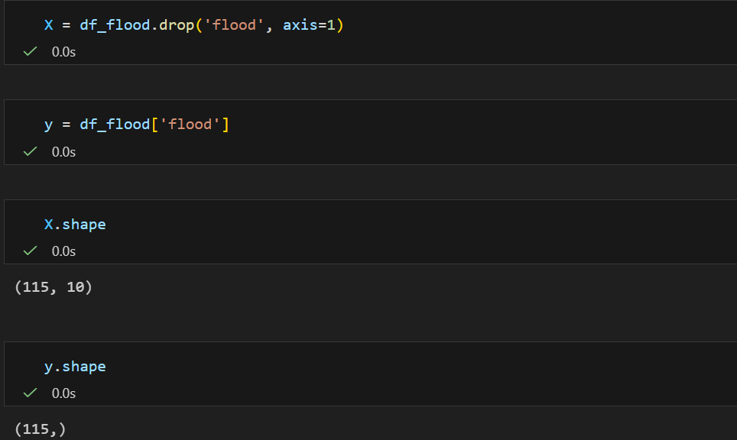.
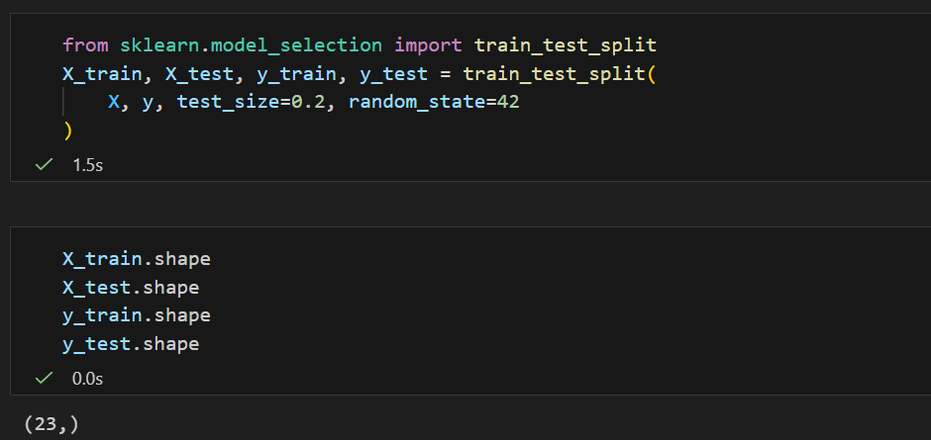
Activity 4: Scaling the Data
Scaling is one of the important processes we have to perform on the dataset, because data measured in different ranges can lead to misleading predictions.
Models such as KNN, Decision Trees, and neural networks benefit from scaled data as they are sensitive to feature magnitudes. We use StandardScaler which standardizes features by removing the mean and scaling to unit variance.
We perform scaling only on the input values (X_train and X_test), not on the target variable.
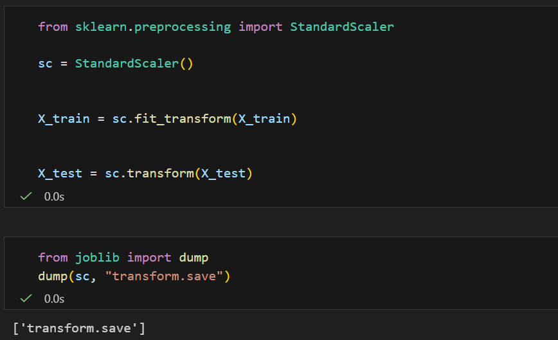
Milestone 4: Model Building
Now our data is cleaned and it's time to build the model. We can train our data on different algorithms. For this project we are applying four classification algorithms to predict flood occurrence. The best model is saved based on its performance.

Activity 1: Decision tree model
A function named decisionTree is created and train and test data are passed as the parameters. Inside the function, DecisionTreeClassifier algorithm is initialized and training data is passed to the model with .fit() function. Test data is predicted with .predict() function and saved in new variable. For evaluating the model, confusion matrix and classification report is done.
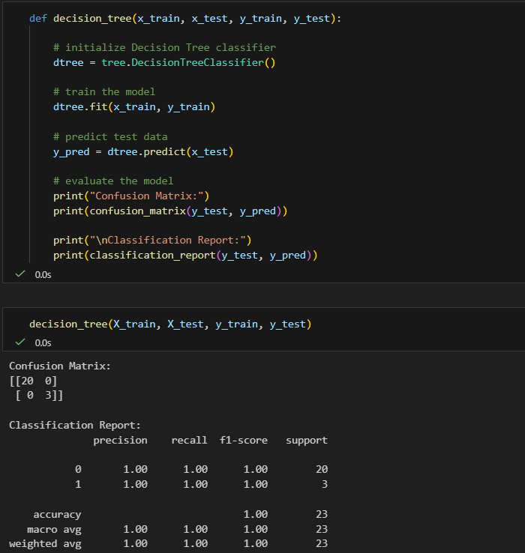

Activity 2: Random Forest Model
A function named random_forest is created and train and test data are passed as the parameters. Inside the function, RandomForestClassifier algorithm is initialized and training data is passed to the model with .fit() function. Test data is predicted with .predict() function and saved in a new variable. For evaluating the model, confusion matrix and classification report are generated.
Random Forest is an ensemble learning method that creates multiple decision trees and combines their predictions to improve accuracy and reduce overfitting. This makes it particularly effective for flood prediction as it can capture complex relationships between environmental features.
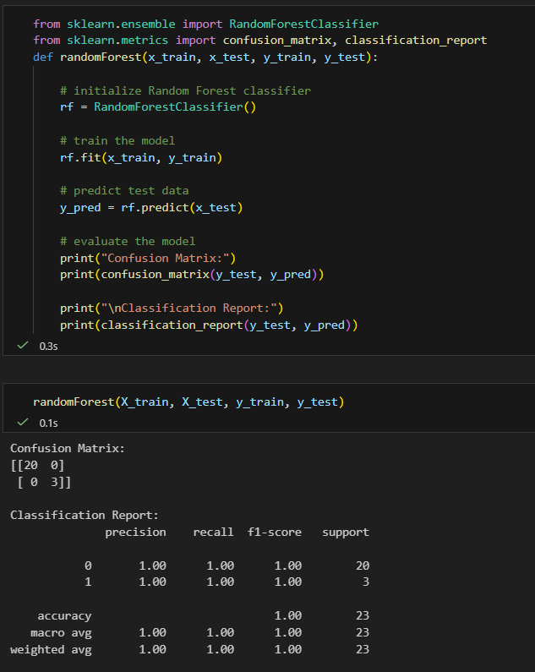

Activity 3: KNN Model
A function named knn is created and train and test data are passed as the parameters. Inside the function, KNeighborsClassifier algorithm is initialized and training data is passed to the model with .fit() function. Test data is predicted with .predict() function and saved in a new variable. For evaluating the model, confusion matrix and classification report are generated.
K-Nearest Neighbors (KNN) is a distance-based algorithm that classifies a data point based on the majority class of its k nearest neighbors. It's effective for flood prediction as it identifies patterns by comparing similar environmental conditions from historical data.
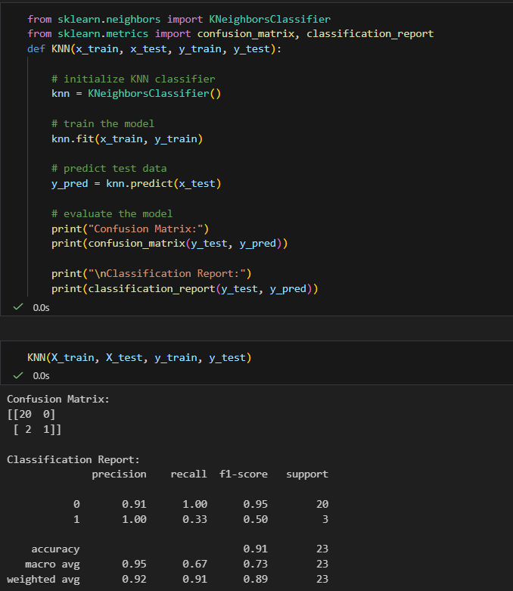

Activity 4: XGBoost Model
A function named xgboost is created and train and test data are passed as the parameters. Inside the function, GradientBoostingClassifier algorithm is initialized and training data is passed to the model with .fit() function. Test data is predicted with .predict() function and saved in a new variable. For evaluating the model, confusion matrix and classification report are generated.
XGBoost (Extreme Gradient Boosting) is an advanced ensemble learning algorithm that builds models sequentially, where each new model corrects errors made by previous models. It's highly effective for flood prediction due to its ability to handle complex patterns and provide superior prediction accuracy.
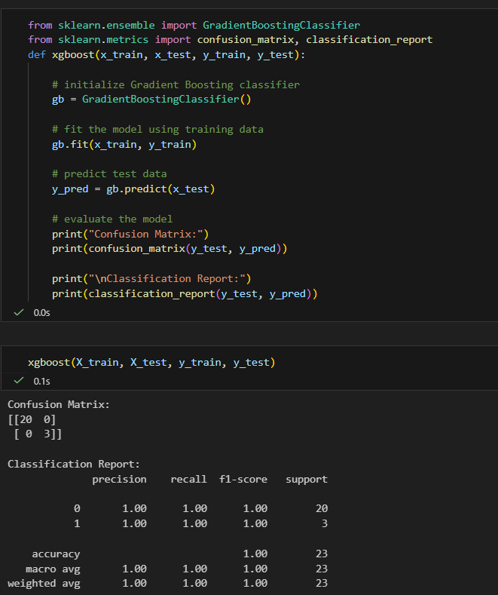
Now let’s see the performance of all the models and save the best model

Activity 5: Compare the Model
For comparing the above four models, compare_model function is defined. This function trains all four algorithms (Decision Tree, Random Forest, KNN, and XGBoost) on the same training data and evaluates their performance on the test data. The accuracy scores of all models are calculated and displayed for comparison.
After calling the function, the results of models are displayed as output. From the four models, we can analyze which algorithm performs best for flood prediction based on the environmental features in our dataset. The model with the highest accuracy on test data is selected for deployment.
Based on the comparison results, XGBoost (Gradient Boosting Classifier) is performing well with the flood dataset, showing superior accuracy in predicting flood occurrences. We consider XGBoost as the best model and proceed to deploy this model in our Flask application.
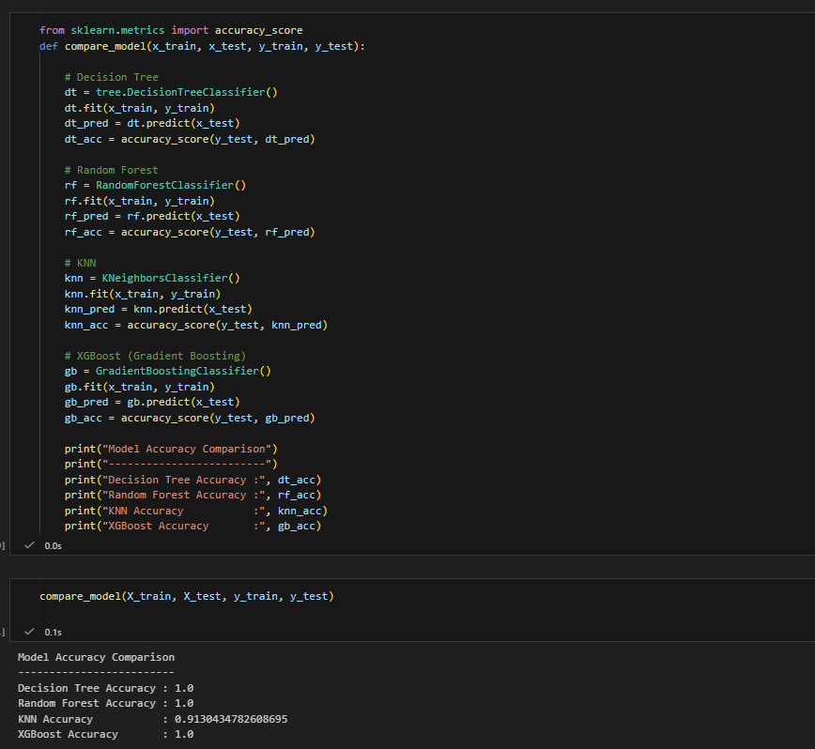

Activity 6: Evaluating performance of the model and saving the model
From sklearn, cross_val_score is used to evaluate the score of the model. On the parameters, we have given rf (model name), x, y, cv (as 5 folds). Our model is performing well. So, we are saving the model by pickle.dump().
Note: To understand cross validation, refer this link. https://towardsdatascience.com/cross-validation-explained-evaluating-estimator-performance-e51e5430ff85.
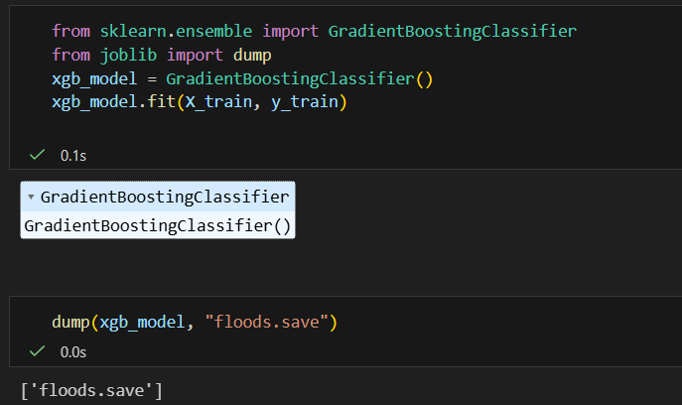

Milestone 5: Application Building
In this section, we will be building a web application that is integrated to the model we built. A UI is provided for the users where they have to enter the values for predictions. The entered values are given to the saved model and the flood prediction is showcased on the UI.
This section has the following tasks:
• Building HTML Pages
• Building server-side script (app.py)
Activity 1: Building HTML Pages
For this project, we have created multiple HTML files for different functionalities and saved them in the templates folder:
• index.html - Landing page for the application
• home.html - Main page with navigation options
• intro.html - Introduction/information page about flood prediction
• image.html - Page for image-based flood prediction input
• imageprediction.html - Page displaying image prediction results
These HTML pages are styled using CSS stored in the static/css folder (styles.css) to provide an attractive and user-friendly interface.
Let's see how our main pages look:
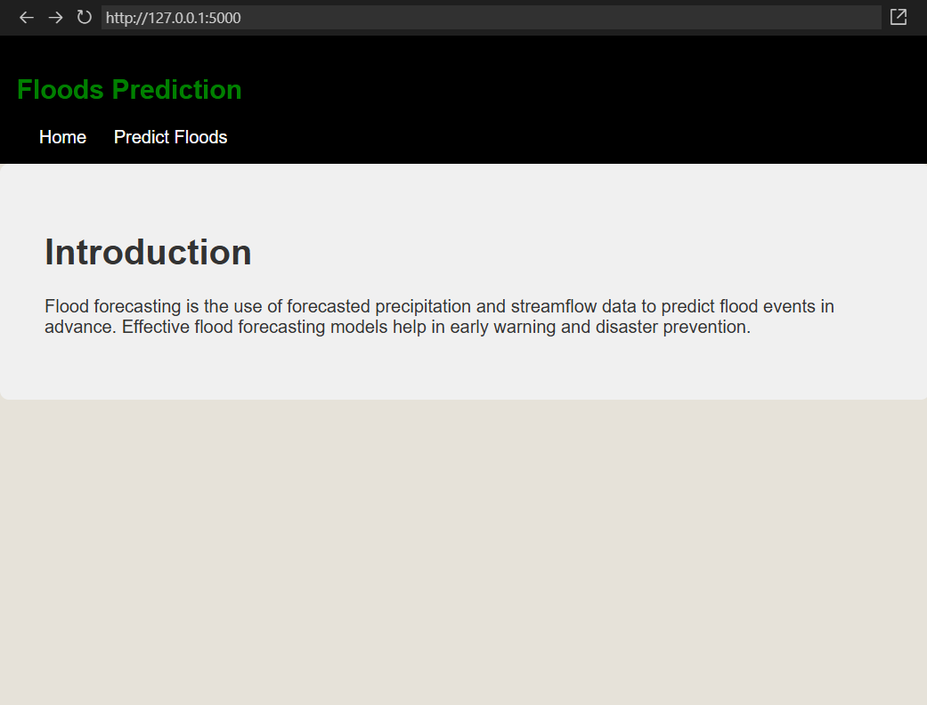
Now when you click on predict button from top right corner you will get redirected to predict.html
Lets look how our predict.html file looks like:
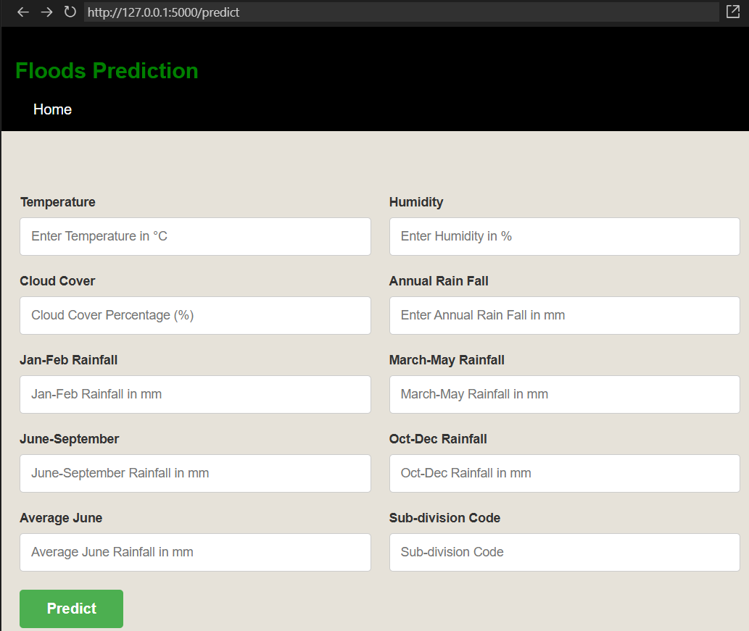
Now when you click on Submit button, you will be redirected to the prediction result page.
Let's look how our result page (imageprediction.html) looks like:
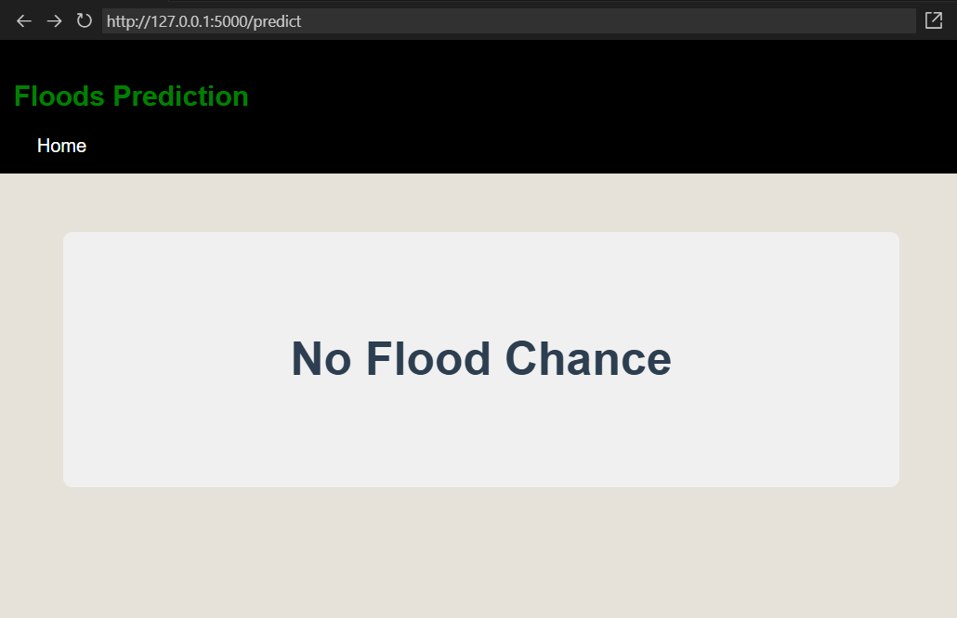
Activity 2: Build Python code:
Import the libraries
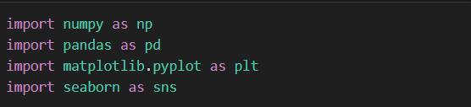
Load the saved model. Importing flask module in the project is mandatory. An object of Flask class is our WSGI application. Flask constructor takes the name of the current module (__name__) as argument.
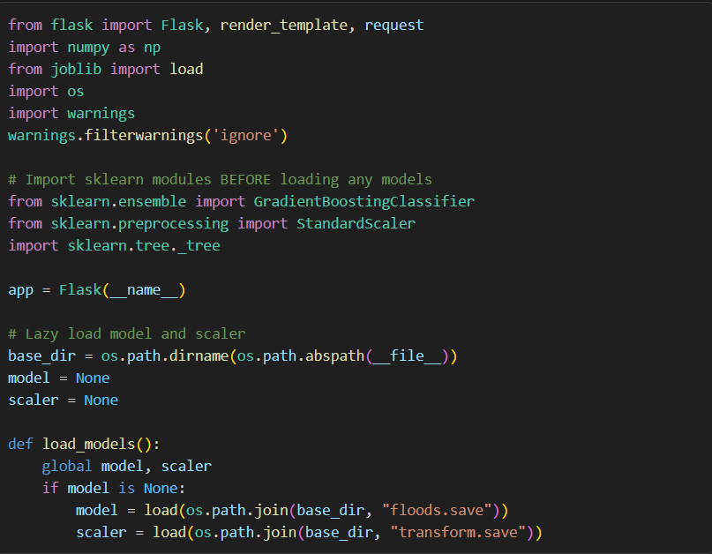
Render HTML page:
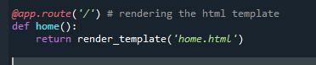
Here we will be using declared constructor to route to the HTML page which we have created earlier.

In the above example, ‘/’ URL is bound with home.html function. Hence, when the home page of the web server is opened in browser, the html page will be rendered. Whenever you enter the values from the html page the values can be retrieved using POST Method.
Retrieves the value from UI:
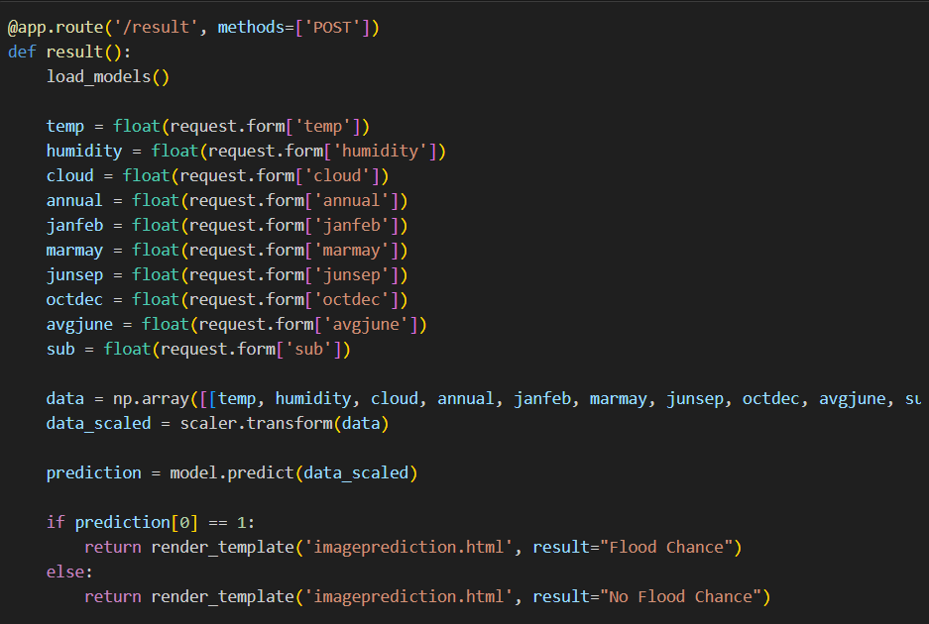

Here we are routing our app to the result() function via the '/result' route. This function retrieves all the environmental input values (temperature, humidity, cloud cover, rainfall data, etc.) from the HTML form using POST request. These values are stored in a numpy array. Before prediction, this array is transformed using the StandardScaler (data_scaled = scaler.transform(data)) to match the training data format. The scaled data is then passed to the model.predict() function. This function returns the prediction (0 for No Flood, 1 for Flood). Based on this prediction value, the appropriate result message ("Flood Chance" or "No Flood Chance") is rendered on the imageprediction.html page.
Main Function:
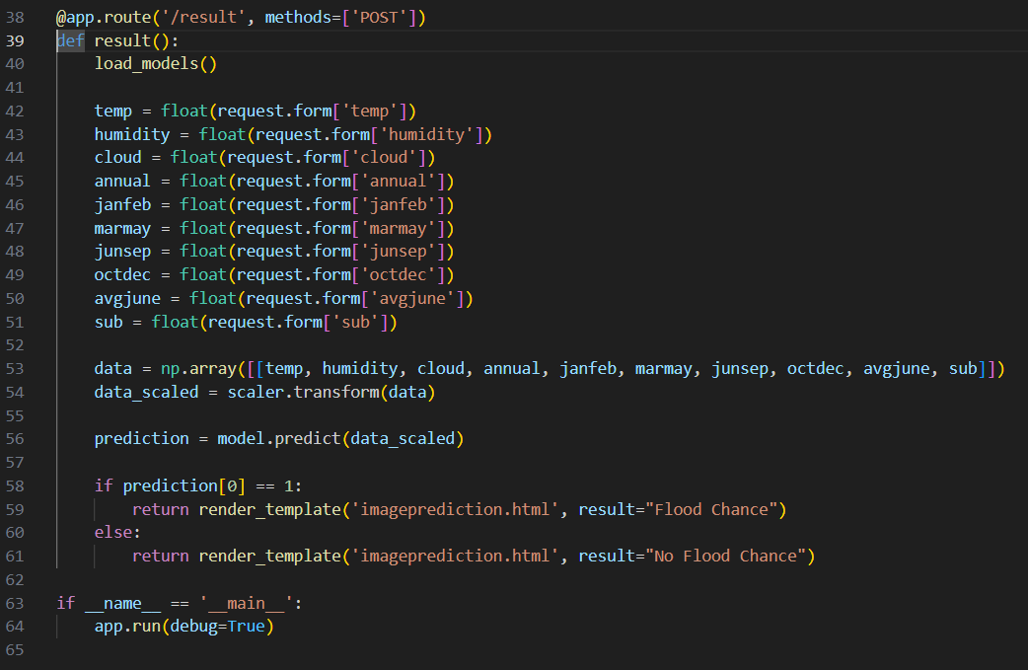
Activity 3: Run the Application
• Open Command Prompt or PowerShell from the start menu
• Navigate to the Flask folder where your app.py script is located:
cd C:\Users\ponna\OneDrive\Desktop\Flood_Prediction\Flask
• Activate the virtual environment and run the application:
C:/Users/ponna/OneDrive/Desktop/Flood_Prediction/.venv/Scripts/python.exe app.py
• The Flask server will start running on http://127.0.0.1:5000 or http://localhost:5000
• Open your web browser and navigate to http://127.0.0.1:5000
• Click on the Predict button from the top right corner to access the prediction form
• Enter the environmental input values (temperature, humidity, rainfall data, etc.)
• Click on the Submit button
• View the flood prediction result on the result page
